Symmetric Shapes
# Source: AI Source: Provided by: [Data Path: Persons Table -> ID Column: 1, Name_En Column: Motasem Essam] -> From: [ChatGPT] on [7/25/2026]
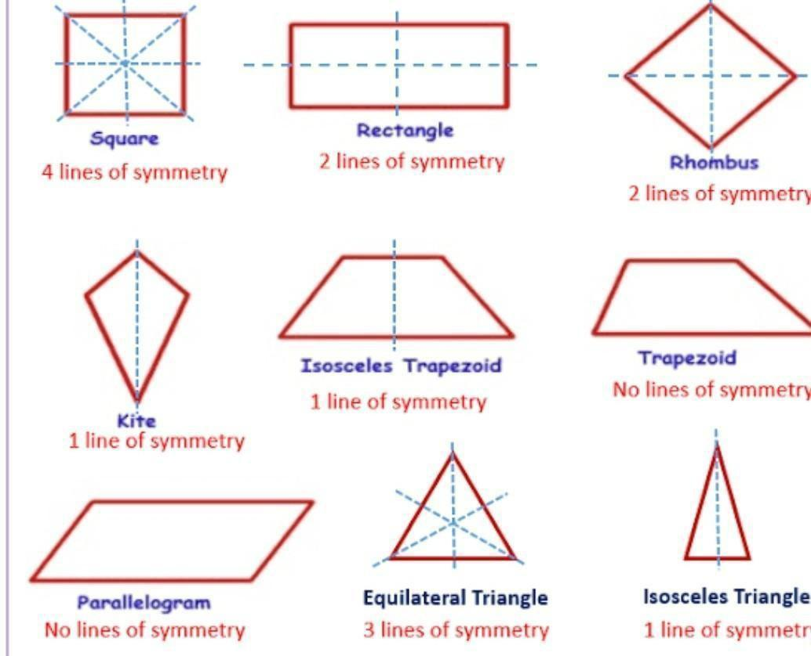
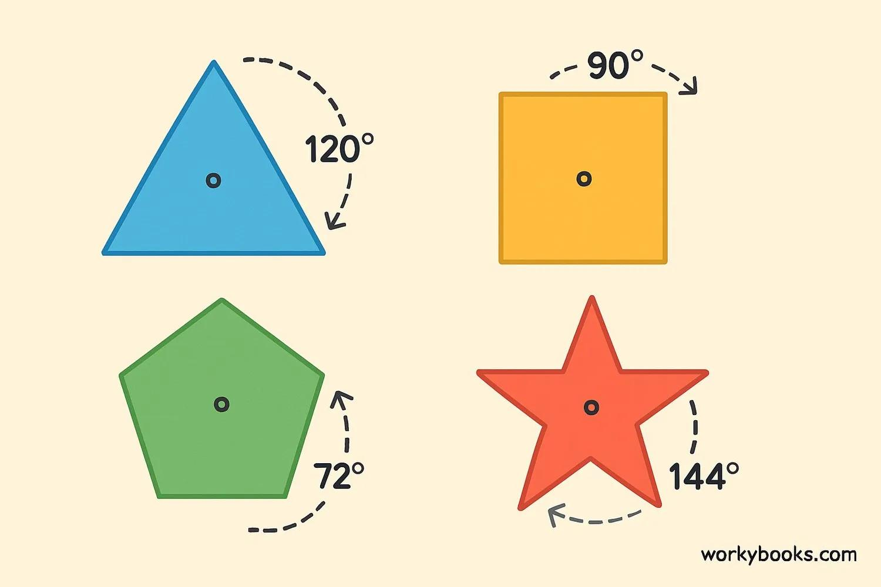
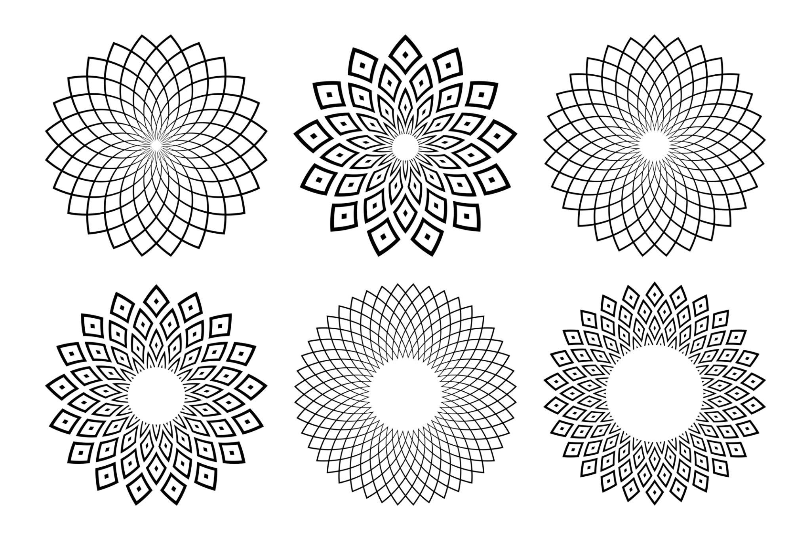
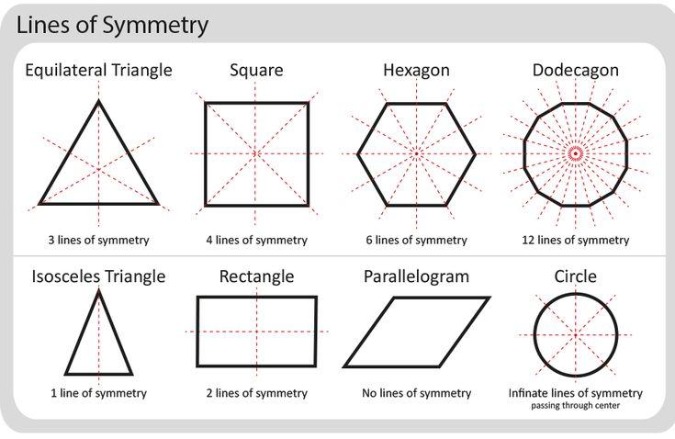
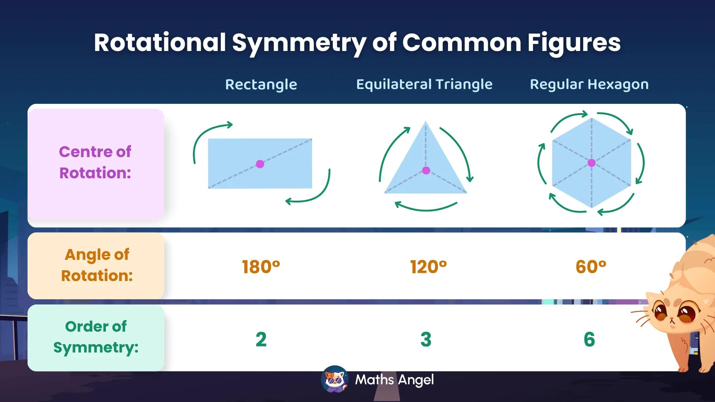

Definition
# Source: AI Source: Provided by: [Data Path: Persons Table -> ID Column: 1, Name_En Column: Motasem Essam] -> From: [ChatGPT] on [7/25/2026]
A Symmetric Shape is a shape that has a symmetry, meaning that the shape remains unchanged under a particular geometric transformation.
The most common types are:
- Reflection Symmetry
- Rotational Symmetry
- Point Symmetry
In simple terms, a shape is symmetric when one part of the shape corresponds to another part in a consistent way.

Fundamental Concept
# Source: AI Source: Provided by: [Data Path: Persons Table -> ID Column: 1, Name_En Column: Motasem Essam] -> From: [ChatGPT] on [7/25/2026]
Symmetry describes a relationship between a shape and a transformation.
For example, a shape has line symmetry if reflecting it across a particular line produces the same shape.
$$\boxed{\text{Shape}\underset{→}{\text{Symmetry Transformation}}\text{Same Shape}}$$
The corresponding parts of the shape are called symmetric parts.

Main Characteristics
# Source: AI Source: Provided by: [Data Path: Persons Table -> ID Column: 1, Name_En Column: Motasem Essam] -> From: [ChatGPT] on [7/25/2026]
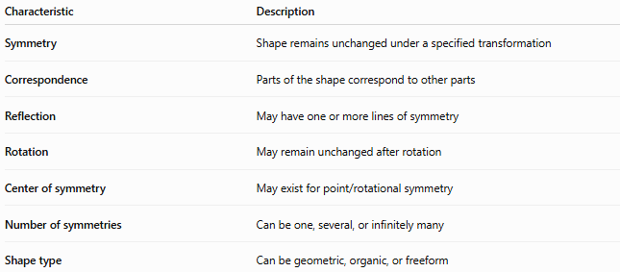
Characteristic | Description
Symmetry | Shape remains unchanged under a specified transformation
Correspondence | Parts of the shape correspond to other parts
Reflection | May have one or more lines of symmetry
Rotation | May remain unchanged after rotation
Center of symmetry | May exist for point/rotational symmetry
Number of symmetries | Can be one, several, or infinitely many
Shape type | Can be geometric, organic, or freeform

Types of Symmetric Shapes
# Source: AI Source: Provided by: [Data Path: Persons Table -> ID Column: 1, Name_En Column: Motasem Essam] -> From: [ChatGPT] on [7/25/2026]
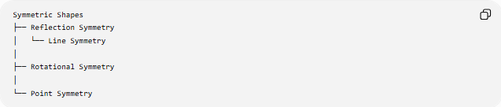
Symmetric Shapes
├── Reflection Symmetry
│ └── Line Symmetry
│
├── Rotational Symmetry
│
└── Point Symmetry
These categories can overlap. A shape may possess more than one type of symmetry.

Line Symmetry
# Source: AI Source: Provided by: [Data Path: Persons Table -> ID Column: 1, Name_En Column: Motasem Essam] -> From: [ChatGPT] on [7/25/2026]
Line Symmetry is symmetry with respect to a line.
A shape has line symmetry if one half of the shape is the mirror image of the other half across a line called the line of symmetry.
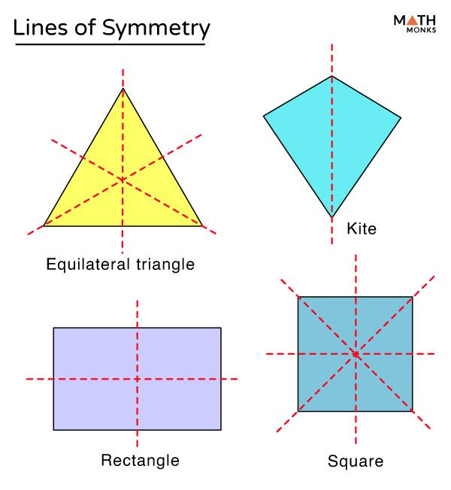
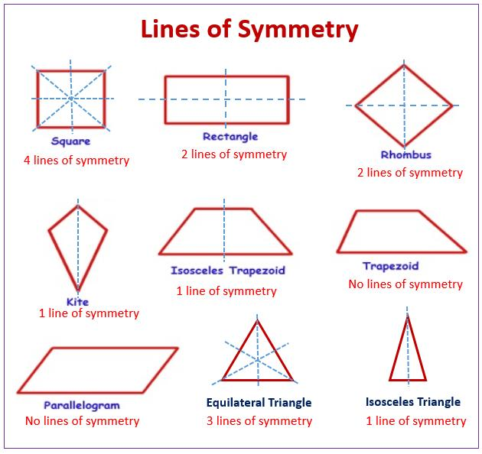
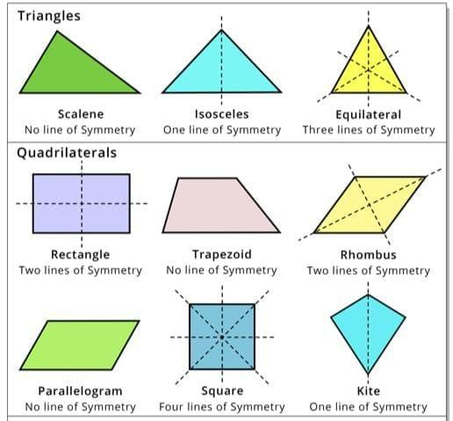
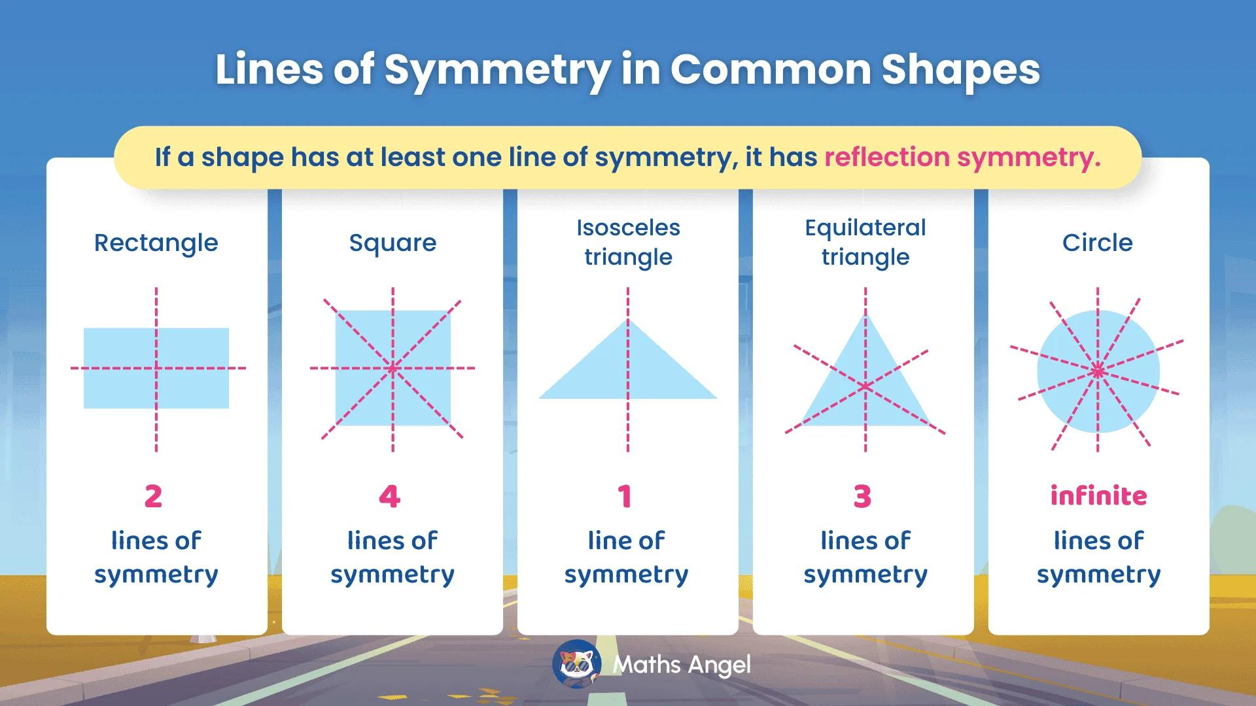
For example, a square has four lines of symmetry.
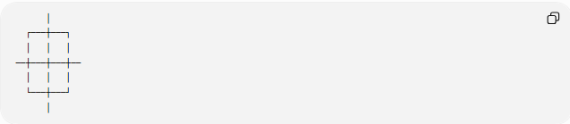
│
┌───┼───┐
│ │ │
──┼───┼───┼──
│ │ │
└───┼───┘
│
The reflection across each symmetry line produces the same square.

Number of Lines of Symmetry
# Source: AI Source: Provided by: [Data Path: Persons Table -> ID Column: 1, Name_En Column: Motasem Essam] -> From: [ChatGPT] on [7/25/2026]
Different shapes have different numbers of lines of symmetry.
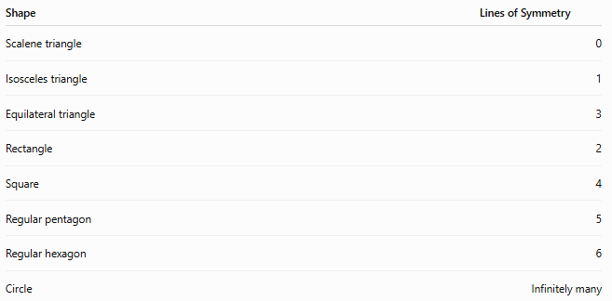
Shape | Lines of Symmetry
Scalene triangle | 0
Isosceles triangle | 1
Equilateral triangle | 3
Rectangle | 2
Square | 4
Regular pentagon | 5
Regular hexagon | 6
Circle | Infinitely many
For a regular $n$-gon:
$$\boxed{\text{Number of lines of symmetry}=n}$$

Rotational Symmetry
# Source: AI Source: Provided by: [Data Path: Persons Table -> ID Column: 1, Name_En Column: Motasem Essam] -> From: [ChatGPT] on [7/25/2026]
A shape has Rotational Symmetry if it coincides with itself after being rotated through an angle smaller than ${360}^{∘}$.
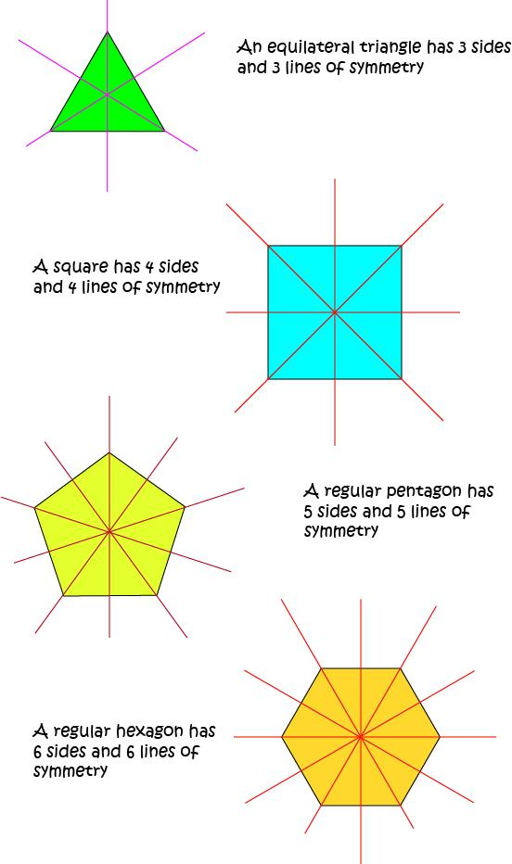
The order of rotational symmetry is the number of times the shape matches itself during one complete ${360}^{∘}$rotation.
For rotational order $n$:
$$\boxed{θ=\frac{{360}^{∘}}{n}}$$
where $θ$is the smallest angle of rotation that maps the shape onto itself.
Examples
- Equilateral triangle → order $3$
- Square → order $4$
- Regular pentagon → order $5$
- Regular hexagon → order $6$

Point Symmetry
# Source: AI Source: Provided by: [Data Path: Persons Table -> ID Column: 1, Name_En Column: Motasem Essam] -> From: [ChatGPT] on [7/25/2026]
A shape has Point Symmetry if every point of the shape corresponds to another point directly opposite it through a common center.
The transformation is equivalent to a rotation of:
$${180}^{∘}$$
about the center.
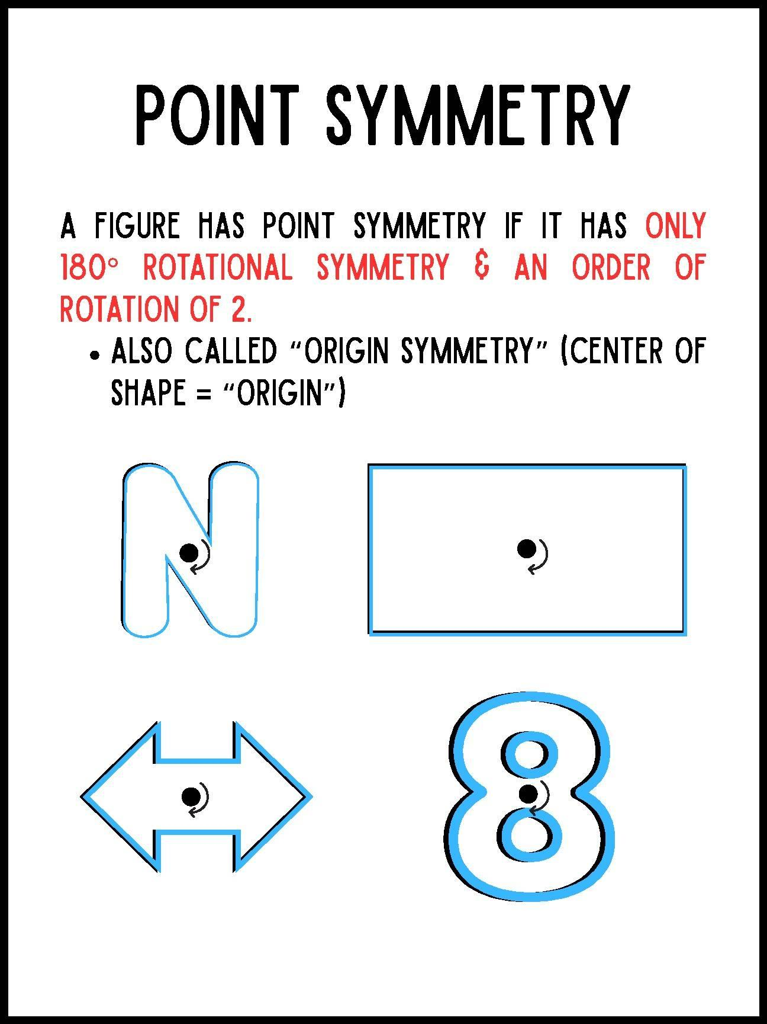
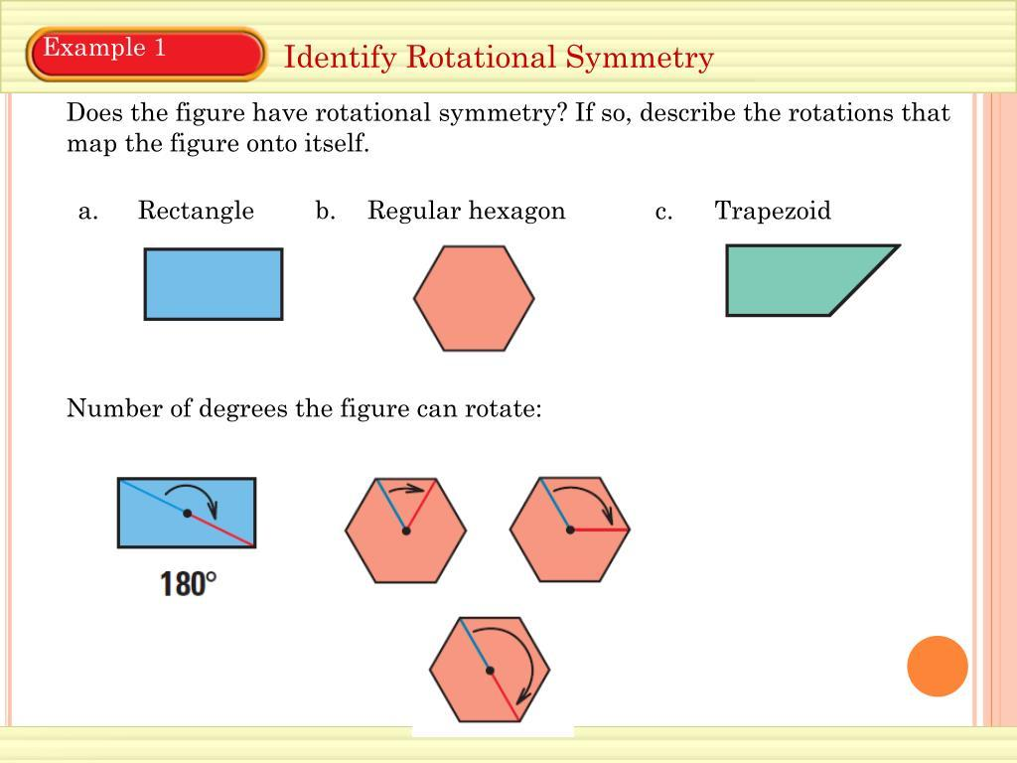
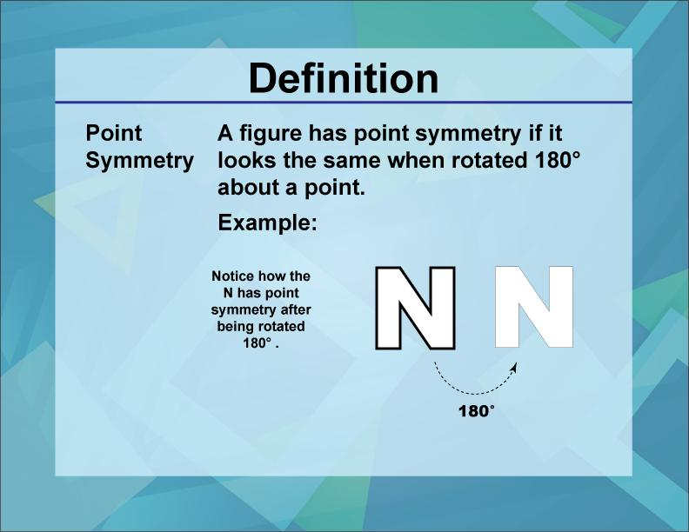
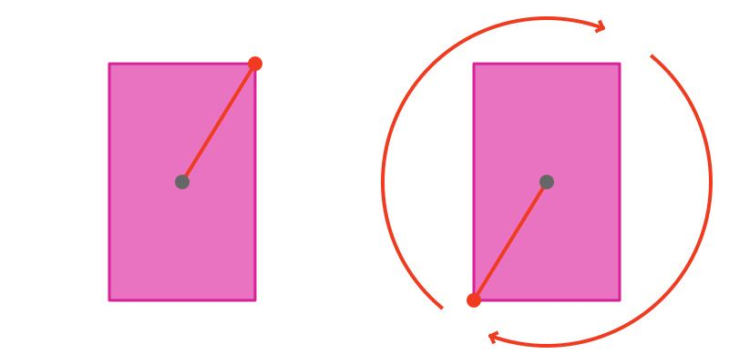
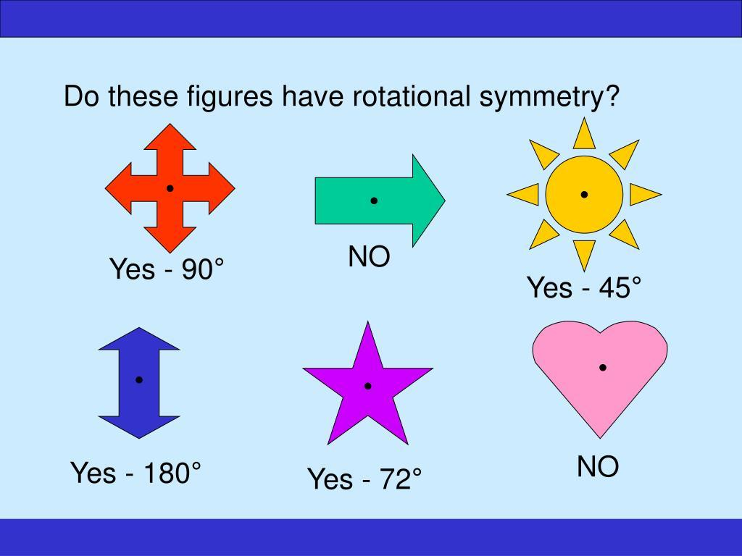
For corresponding points $A$and $A^{'}$, the center $O$is the midpoint:
$$\boxed{OA=OA^{'}}$$
and $A,O,A^{'}$are collinear.

Common Symmetric Shapes
# Source: AI Source: Provided by: [Data Path: Persons Table -> ID Column: 1, Name_En Column: Motasem Essam] -> From: [ChatGPT] on [7/25/2026]
Circle
A circle has:
- Infinitely many lines of symmetry
- Infinitely many rotational symmetries
Every diameter is a line of symmetry.
Square
A square has:
- 4 lines of symmetry
- Rotational symmetry of order 4
- Point symmetry
Rectangle
A non-square rectangle has:
- 2 lines of symmetry
- Rotational symmetry of order 2
- Point symmetry
Equilateral Triangle
An equilateral triangle has:
- 3 lines of symmetry
- Rotational symmetry of order 3
- No point symmetry

Symmetry of Regular Polygons
# Source: AI Source: Provided by: [Data Path: Persons Table -> ID Column: 1, Name_En Column: Motasem Essam] -> From: [ChatGPT] on [7/25/2026]
Regular polygons have particularly strong symmetry.
For a regular $n$-gon:
$$\boxed{\text{Lines of symmetry}=n}$$
and:
$$\boxed{\text{Rotational order}=n}$$
Examples:
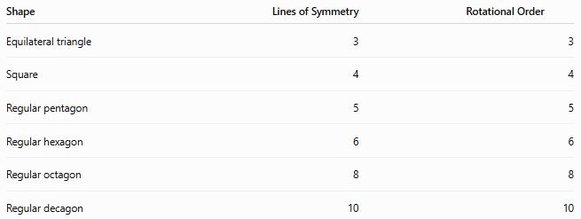
Shape | Lines of Symmetry | Rotational Order
Equilateral triangle | 3 | 3
Square | 4 | 4
Regular pentagon | 5 | 5
Regular hexagon | 6 | 6
Regular octagon | 8 | 8
Regular decagon | 10 | 10

Symmetric vs Asymmetric Shapes
# Source: AI Source: Provided by: [Data Path: Persons Table -> ID Column: 1, Name_En Column: Motasem Essam] -> From: [ChatGPT] on [7/25/2026]
An Asymmetric Shape does not possess the particular symmetry being considered.
For example:
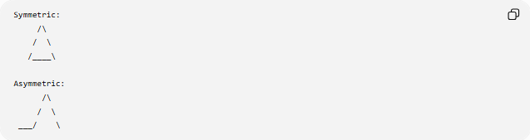
Symmetric:
/\
/ \
/____\

Asymmetric:
/\
/ \
___/ \
However, symmetry must always be specified by transformation type.
A shape can lack line symmetry while still having rotational symmetry.

Symmetric Shapes vs Regular Shapes
# Source: AI Source: Provided by: [Data Path: Persons Table -> ID Column: 1, Name_En Column: Motasem Essam] -> From: [ChatGPT] on [7/25/2026]
These concepts are related but not identical.
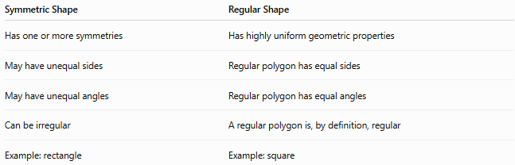
Symmetric Shape | Regular Shape
Has one or more symmetries | Has highly uniform geometric properties
May have unequal sides | Regular polygon has equal sides
May have unequal angles | Regular polygon has equal angles
Can be irregular | A regular polygon is, by definition, regular
Example: rectangle | Example: square
A rectangle is symmetric but is not necessarily a regular polygon.

Symmetry in Organic and Freeform Shapes
# Source: AI Source: Provided by: [Data Path: Persons Table -> ID Column: 1, Name_En Column: Motasem Essam] -> From: [ChatGPT] on [7/25/2026]
Symmetry is not limited to geometric shapes.
An organic or freeform shape can also be symmetric.
For example:
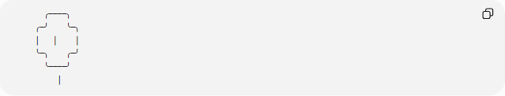
╭────╮
╭─╯ ╰─╮
│ │ │
╰─╮ ╭─╯
╰────╯
│
Natural examples may have:
- Approximate symmetry
- Bilateral symmetry
- Radial symmetry
- Irregular or imperfect symmetry
Therefore:
$$\boxed{\text{Symmetry is a property of a shape, not a separate shape family only}}$$

Symmetry Classification
# Source: AI Source: Provided by: [Data Path: Persons Table -> ID Column: 1, Name_En Column: Motasem Essam] -> From: [ChatGPT] on [7/25/2026]
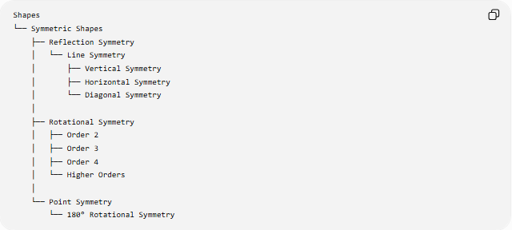
Shapes
└── Symmetric Shapes
├── Reflection Symmetry
│ └── Line Symmetry
│ ├── Vertical Symmetry
│ ├── Horizontal Symmetry
│ └── Diagonal Symmetry
│
├── Rotational Symmetry
│ ├── Order 2
│ ├── Order 3
│ ├── Order 4
│ └── Higher Orders
│
└── Point Symmetry
└── 180° Rotational Symmetry
A shape can belong to multiple branches simultaneously.
For example:
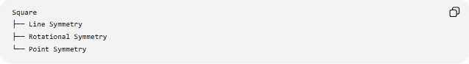
Square
├── Line Symmetry
├── Rotational Symmetry
└── Point Symmetry

Important Formulas
# Source: AI Source: Provided by: [Data Path: Persons Table -> ID Column: 1, Name_En Column: Motasem Essam] -> From: [ChatGPT] on [7/25/2026]
Rotational Angle
For rotational symmetry of order $n$:
$$\boxed{θ=\frac{{360}^{∘}}{n}}$$
Regular Polygon
For a regular $n$-gon:
$$\boxed{\text{Number of symmetry lines}=n} \\ \boxed{\text{Rotational order}=n}$$
Point Symmetry
Point symmetry corresponds to:
$$\boxed{{180}^{∘}\text{ rotation}}$$

Examples
# Source: AI Source: Provided by: [Data Path: Persons Table -> ID Column: 1, Name_En Column: Motasem Essam] -> From: [ChatGPT] on [7/25/2026]
Common symmetric shapes include:
- Circle
- Square
- Rectangle
- Equilateral triangle
- Regular polygons
- Rhombus
- Isosceles triangle
- Some stars
- Some leaves
- Some flowers
- Some decorative freeform shapes
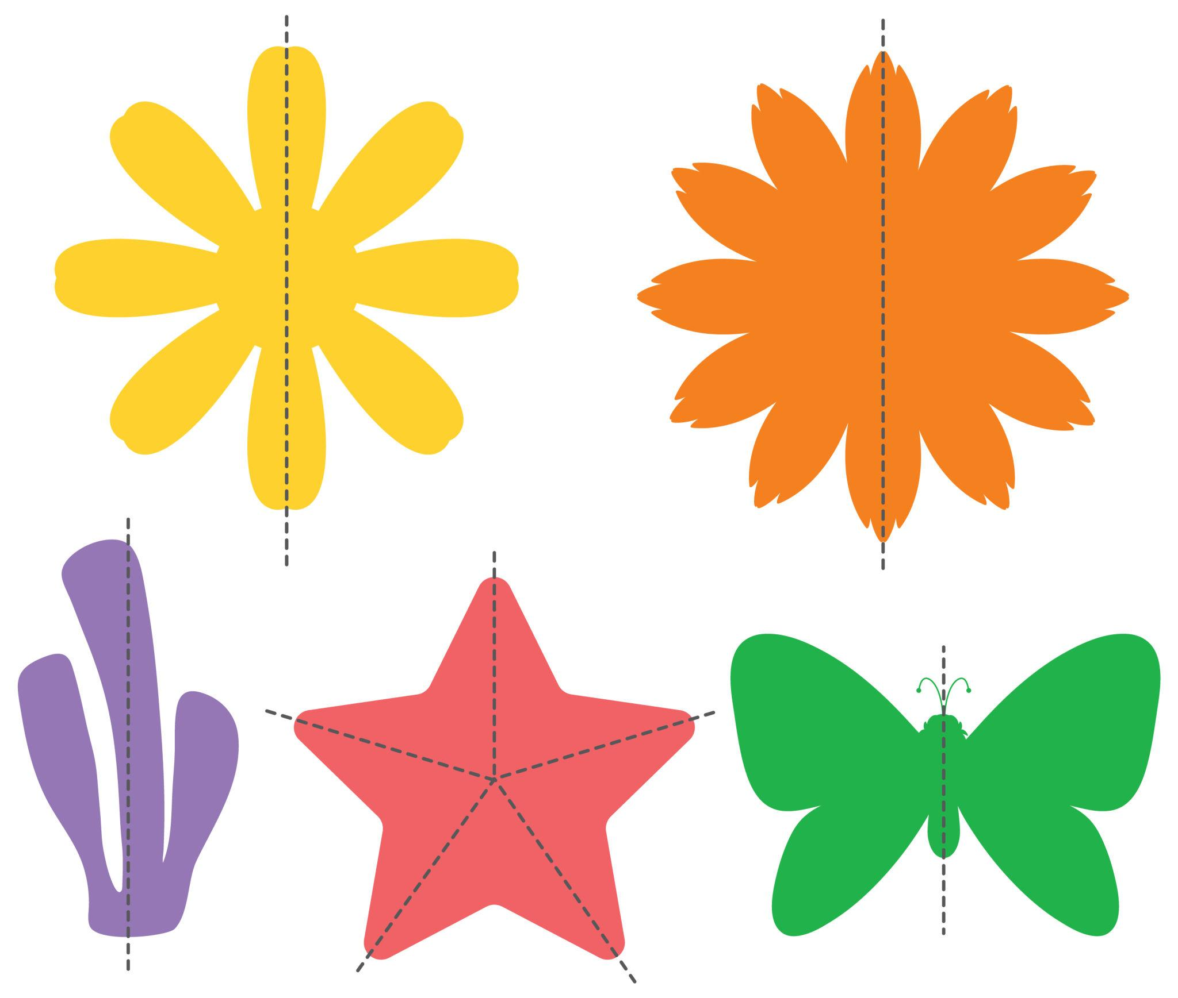
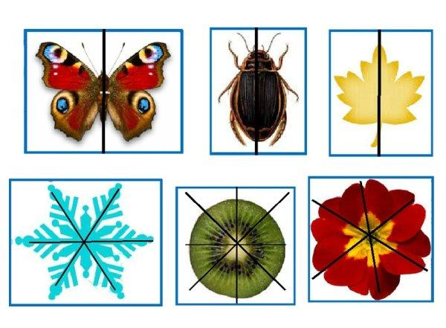
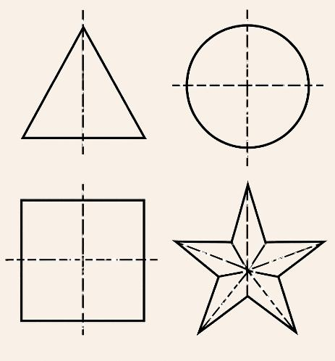
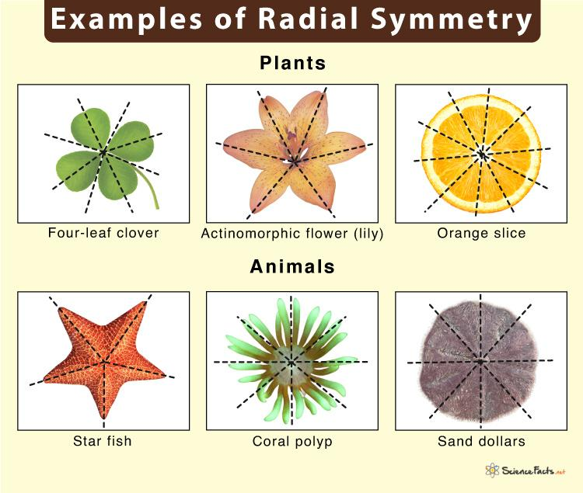

Key Points
# Source: AI Source: Provided by: [Data Path: Persons Table -> ID Column: 1, Name_En Column: Motasem Essam] -> From: [ChatGPT] on [7/25/2026]
- A Symmetric Shape remains unchanged under a particular symmetry transformation.
- The major types are line symmetry, rotational symmetry, and point symmetry.
- A line of symmetry divides a shape into corresponding mirror-image parts.
- Rotational symmetry is described by its order.
- Point symmetry corresponds to a ${180}^{∘}$rotation.
- A shape can have more than one type of symmetry.
- Regular polygons have a highly organized symmetry structure.
- Symmetry can also occur in organic and freeform shapes.
- Symmetry is a property or relationship of a shape, rather than necessarily a distinct geometric shape category.

Conclusion
# Source: AI Source: Provided by: [Data Path: Persons Table -> ID Column: 1, Name_En Column: Motasem Essam] -> From: [ChatGPT] on [7/25/2026]
A Symmetric Shape is a shape whose structure is preserved under one or more geometric transformations. Its symmetry may be expressed through reflection across a line, rotation about a point, or ${180}^{∘}$point symmetry. Symmetry provides a systematic way to describe how different parts of a shape correspond to one another.

